Final Grade Appeal for Operations Management Course

Instructor: Felicia Roquemore

Course number: B360/MAN3504

Class: Operations Management

Felicia Roquemore,

I am writing in regard to appeal the decision made based on the final grade I received in the Operations management class, course number: B360/MAN3504.

Due to extenuating circumstances based in part by my disability & medical conditions. Which is on file and submitted to provide accommodations and still under review. From February 11th through February 14th I was in remission for a treatment and inactive due to an infection that made me very ill.

I suffer from a chronic pain & illness and have a complicated medical history from active duty service In the US military. At the time I was incapacitated with only a mobile device in my pocket going through what can only be described as very immense physical pain.

I had no access to a computer let alone had my credentials with my login information to log in to the Rasmussen portal and access a mailer to notify my instructor. nor did I have anyone that could access these resources for me.

After I got out, I called my advisor Jennifer Lothenbach who advised me after discussing that my accommodation from previous school (HCC) for my disability did not carry over due to formality that is required by Rasmussen. She advised me to contact my instructor and to offer showing a doctor’s letter to verify my medical absence.

After doing so I called and spoke to you. After doing so you told me that you would accept my final project and only my final project, and that I did not need to send you my doctors notes after offering to send them. You assured me that you had reviewed the course project and would give me credit for the assignment putting my grade at as passing with a C.

After a few weeks when going to print off my transcript I found that my final grade never changed and was advised of appeal process.

I had the assignment done the week before aside from minor changes you had instructed me to fix which I did. I am not receiving a grade because something completely out of my control kept from loading a simple document and submitting a single email.

I cordially ask that you reconsider your final decision in accepting my final course project and crediting me as discussed, Thank you.

*Student: Shaun Pritchard*

*Wednesday, March 11, 2020*

*Copy of doctors note:*

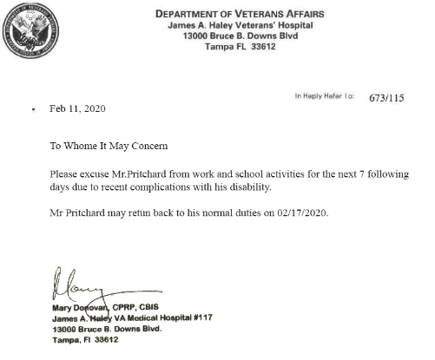

*Disability:*

